**PANDIT DEENDAYAL ENERGY UNIVERSITY**

**Raisan, Gandhinagar – 382 426, Gujarat, India**

**B.TECH-­­­­­­­­­­­2020-2024**

**Dating Web Application**



Submitted to : Prof. Chintan Bhatt

**Department of Computer Engineering**

## School of Energy Technology, Pandit Deendayal Energy University

**Abstract**

With the proliferation of smartphones and the increasing reliance on digital technology in modern society, dating apps have emerged as a popular platform for individuals seeking romantic connections. This abstract provides a concise overview of the main findings and implications of a report on dating apps.

The report examines the evolution of dating apps, their impact on modern dating culture, and the challenges and opportunities they present. It delves into the ways in which dating apps have transformed traditional dating norms, including changes in communication patterns, relationship dynamics, and user behaviors. The report also highlights the role of dating apps in shaping social interactions, self-presentation, and the construction of identity in the digital realm.

Drawing on existing literature and research, the report synthesizes key insights on the motivations, experiences, and outcomes of dating app use. It analyzes the factors that influence app adoption and usage, such as age, gender, socio-economic status, and cultural context. It also explores the potential benefits of dating apps, such as increased access to potential partners, expanded dating opportunities, and enhanced self-expression. However, the report also acknowledges the potential risks and drawbacks of dating app use, such as privacy concerns, online harassment, and the commodification of relationships.

**Table of Contents**

1. Introduction

- Background and motivation

- Objectives of the project

2. Methodology

- Description of the development process

- Tools and technologies used

- System architecture and database design

3. Implementation

- Backend development using NodeJs and ExpressJs

- Frontend development using ReactJs with Database MongoDb

- Integration of various components and testing

4. Results and discussion

- Description of the time table web application

- Evaluation of the application's performance and user interface

5. Conclusion and future work

- Summary of the project

- Discussion of the limitations and potential improvements

- Conclusion and future directions

6. References

**Introduction**

S

7069

Copyright © 2018, IGI Global. Copying or distributing in print or electronic forms without written permission of IGI Global is prohibited.

Category: Social Networking and Computing

DOI: 10.4018/978-1-5225-2255-3.ch613

Online Dating/Dating Apps

INTRODUCTION

Over the past several years, online dating services

are increasingly becoming popular venues for

finding romantic relationships. In 2012, Match.

com reported that one in six marriages started

online (Ramirez, Sumner, Fleuriet & Cole, 2015).

In 2013, the online mating services brought $2.1

billion (Ginsberg, 2015) whereas compared to ten

years ago, in 2004, the dating industry revenue

was only $473 million. Nowadays, there are many

online dating sites such as Match.com, eHarmony,

and PerfectMatch.com, with over 50 million us-

ers combined (Consumer Rankings., 2012), and

the online dating business keeps growing (Visual

Economics Credit Loan blog, 2015). Online dating

refers to web sites and apps that facilitate romantic

relationships’ initiation by offering users (1) access

to the profiles of potential romantic candidates, (2)

a communication channel to initiate contact, and

(3) a romantic compatibility matching-algorithm

to be paired for potential romantic initiation (see

Finkel, Eastwick, Karney, Reis & Sprecher, 2012).

Indeed, most online dating platforms are similarly

structured (Rosen, Cheever, Cummings & Felt,

2008), in general: users post a photograph and

answer questions in regards to personal informa-

tion and other relevant demographics; however,

there is considerable variance among online dating

forums with regard to users’ level of involvement,

interaction, and self-disclosure.

Despite the array of online dating sites and

apps, a new online dating app entered to the

online dating market, and it is taking over the

entire online love business: Tinder. The new app

just entered to the market in 2012, and, two years

later, it reached approximately 30 million users,

almost a third of the total online dating popula-

tion (e.g., 96 million users) (Forbes, November

2014). Thus, the popularity of the app has rapidly

grown. Tinder app innovates the usual online dat-

ing service explained above, by providing users a

seemingly endless selection of photos of potential

mates without the need to answer questionnaires

or forms (Bertoni, 2014a); then, the algorithm

of the app links users’ contacts from Facebook

profiles to provide photographs of potential ro-

mantic candidates. After solely looking at photos

of potential mates, users swipe right if they like

a person and, by the contrary, swipe left if not

(Bertoni, 2014a); finally, if both parties like each

other, the platform provides a parallel interface

to send messages to each other to decide whether

or not to meet in person and exchange personal

contact information.

S

7069

Copyright © 2018, IGI Global. Copying or distributing in print or electronic forms without written permission of IGI Global is prohibited.

Category: Social Networking and Computing

DOI: 10.4018/978-1-5225-2255-3.ch613

Online Dating/Dating Apps

INTRODUCTION

Over the past several years, online dating services

are increasingly becoming popular venues for

finding romantic relationships. In 2012, Match.

com reported that one in six marriages started

online (Ramirez, Sumner, Fleuriet & Cole, 2015).

In 2013, the online mating services brought $2.1

billion (Ginsberg, 2015) whereas compared to ten

years ago, in 2004, the dating industry revenue

was only $473 million. Nowadays, there are many

online dating sites such as Match.com, eHarmony,

and PerfectMatch.com, with over 50 million us-

ers combined (Consumer Rankings., 2012), and

the online dating business keeps growing (Visual

Economics Credit Loan blog, 2015). Online dating

refers to web sites and apps that facilitate romantic

relationships’ initiation by offering users (1) access

to the profiles of potential romantic candidates, (2)

a communication channel to initiate contact, and

(3) a romantic compatibility matching-algorithm

to be paired for potential romantic initiation (see

Finkel, Eastwick, Karney, Reis & Sprecher, 2012).

Indeed, most online dating platforms are similarly

structured (Rosen, Cheever, Cummings & Felt,

2008), in general: users post a photograph and

answer questions in regards to personal informa-

tion and other relevant demographics; however,

there is considerable variance among online dating

forums with regard to users’ level of involvement,

interaction, and self-disclosure.

Despite the array of online dating sites and

apps, a new online dating app entered to the

online dating market, and it is taking over the

entire online love business: Tinder. The new app

just entered to the market in 2012, and, two years

later, it reached approximately 30 million users,

almost a third of the total online dating popula-

tion (e.g., 96 million users) (Forbes, November

2014). Thus, the popularity of the app has rapidly

grown. Tinder app innovates the usual online dat-

ing service explained above, by providing users a

seemingly endless selection of photos of potential

mates without the need to answer questionnaires

or forms (Bertoni, 2014a); then, the algorithm

of the app links users’ contacts from Facebook

profiles to provide photographs of potential ro-

mantic candidates. After solely looking at photos

of potential mates, users swipe right if they like

a person and, by the contrary, swipe left if not

(Bertoni, 2014a); finally, if both parties like each

other, the platform provides a parallel interface

to send messages to each other to decide whether

or not to meet in person and exchange personal

contact information.

S

7069

Copyright © 2018, IGI Global. Copying or distributing in print or electronic forms without written permission of IGI Global is prohibited.

Category: Social Networking and Computing

DOI: 10.4018/978-1-5225-2255-3.ch613

Online Dating/Dating Apps

INTRODUCTION

Over the past several years, online dating services

are increasingly becoming popular venues for

finding romantic relationships. In 2012, Match.

com reported that one in six marriages started

online (Ramirez, Sumner, Fleuriet & Cole, 2015).

In 2013, the online mating services brought $2.1

billion (Ginsberg, 2015) whereas compared to ten

years ago, in 2004, the dating industry revenue

was only $473 million. Nowadays, there are many

online dating sites such as Match.com, eHarmony,

and PerfectMatch.com, with over 50 million us-

ers combined (Consumer Rankings., 2012), and

the online dating business keeps growing (Visual

Economics Credit Loan blog, 2015). Online dating

refers to web sites and apps that facilitate romantic

relationships’ initiation by offering users (1) access

to the profiles of potential romantic candidates, (2)

a communication channel to initiate contact, and

(3) a romantic compatibility matching-algorithm

to be paired for potential romantic initiation (see

Finkel, Eastwick, Karney, Reis & Sprecher, 2012).

Indeed, most online dating platforms are similarly

structured (Rosen, Cheever, Cummings & Felt,

2008), in general: users post a photograph and

answer questions in regards to personal informa-

tion and other relevant demographics; however,

there is considerable variance among online dating

forums with regard to users’ level of involvement,

interaction, and self-disclosure

Online dating has become increasingly popular over the years, with more and more people turning to dating apps and websites to find romantic partners. This trend has been further accelerated by the COVID-19 pandemic, which has limited opportunities for social interaction and dating in person. As a result, the demand for online dating services has risen sharply.

To meet this demand, our team has developed a dating app that utilizes cutting-edge web technologies and frameworks to provide a seamless and engaging user experience. The app is designed to help users find their ideal match by allowing them to create a personalized profile, search for potential partners based on specific criteria, and communicate with them through a secure messaging system.

The app was built using React for front-end development and Express and Node.js for the backend. React provides a robust and scalable framework for building the user interface, while Express and Node.js enable fast and efficient server-side processing of data and business logic. Together, these technologies form a powerful platform for creating a modern and user-friendly dating app.

The purpose of this report is to provide insights into the development process of our dating app, including the design, implementation, and testing of both the front-end and back-end components.

**Background and Motivation:**

Background:

Dating apps have rapidly gained popularity in recent years, transforming the way people approach dating and relationships. These apps provide a digital platform that allows users to create profiles, search for potential partners, and communicate with others in hopes of forming romantic connections. Dating apps offer a convenient and accessible way to meet new people, especially in the era of digital communication and social media. They have become a significant part of modern dating culture, with millions of users worldwide engaging in online dating through these platforms.

Motivation:

The growing prevalence and impact of dating apps on contemporary dating culture have sparked significant interest among researchers, practitioners, and the general public. There is a need for a deeper understanding of the implications of dating apps on relationships, human behavior, and society as a whole. The motivation behind this report is to explore and analyze the multifaceted aspects of dating apps and their effects on modern dating dynamics.

**Objectives**

The report aims to provide a comprehensive overview of the phenomenon of dating apps, examining their evolution, impact on dating culture, and the challenges and opportunities they present. The main objectives of the project include:

1. To explore the ways in which dating apps have transformed traditional dating norms, including changes in communication patterns, relationship dynamics, and user behaviors.
2. To examine the role of dating apps in shaping social interactions, self-presentation, and the construction of identity in the digital realm.
3. To analyze the factors that influence dating app adoption and usage, such as age, gender, socio-economic status, and cultural context.
4. To highlight the potential benefits and risks of dating app use, including increased access to potential partners, expanded dating opportunities, and concerns related to privacy, online harassment, and the commodification of relationships.
5. To contribute to the existing literature on dating apps and offer valuable insights for researchers, practitioners, and individuals interested in the intersection of technology and romance in the digital age.

**Methodology**

1. Requirement gathering: In this stage, we identified the key features and functionalities of a dating app, based on market research and user feedback. We also created user personas to understand the needs and preferences of our target audience.
2. Design: We created wireframes and prototypes of the user interface using tools like Sketch and Figma. We also defined the data models and database schema for the backend.
3. Development: We used React for the front-end development, including components, state management, and routing. We used Express and Node.js for the backend development, including API creation, database connectivity, and business logic implementation. We also integrated third-party libraries for authentication, messaging, and payment processing.
4. Testing: We conducted manual and automated testing of the app to ensure that it met the functional and non-functional requirements. We also performed load testing to assess the app's performance under heavy usage.

**Tools and Technologies used:**

1. NodeJs
2. React
3. MongoDb

**Implementation**

**Backend development using Nodejs:**

The backend of a dating app is responsible for handling server-side logic, data storage, and communication with external services, such as databases and APIs. Node.js, a JavaScript runtime, along with Express.js, a widely used web application framework for Node.js, can be used to build a robust backend for a dating app.

Node.js provides an event-driven, non-blocking I/O model that makes it highly scalable and efficient for building server-side applications. It allows developers to write server-side code in JavaScript, which offers a consistent and familiar language for both frontend and backend development.

Express.js, on the other hand, is a minimalistic and flexible web application framework that provides a set of powerful features for building web applications. It simplifies the development of APIs, routing, middleware, and authentication, making it a popular choice for building RESTful APIs, which are commonly used in modern web applications, including dating apps

1. Setting up the Node.js environment: Install Node.js on the server, set up the required dependencies, and configure the environment for development or production.
2. Creating the Express.js application: Create an Express.js application that will serve as the backend server for the dating app. Define the routes, middleware, and controllers for handling different API endpoints.
3. Implementing API endpoints: Define and implement the required API endpoints for the dating app, such as user registration, login, profile creation, and data retrieval. Use Express.js route handlers and middleware to handle the incoming requests, validate the data, and interact with the database.
4. Implementing authentication and authorization: Implement authentication and authorization mechanisms to ensure secure access to the app's resources. Use popular authentication libraries, such as Passport.js, to handle authentication using various strategies, such as JWT, OAuth, or social media logins.
5. Integrating with databases and external services: Integrate the backend with databases, such as MongoDB, MySQL, or PostgreSQL, to store and retrieve user data. Implement database models, queries, and validations to ensure data integrity and security. Additionally, integrate with external services, such as SMS gateways, email services, or third-party APIs for additional functionalities.

**Front End Development**

1. User interface design: We used React to build the front-end user interface of our dating app. The user interface was designed to be clean, modern, and intuitive. We used Material-UI, a popular React component library, to implement common UI elements such as buttons, forms, and icons.
2. State management: We used Redux, a predictable state container for JavaScript applications, to manage the application state. This allowed us to have a centralized state management system that can be easily accessed by any component in the application.
3. Routing: We used React Router, a powerful routing library for React, to handle client-side routing in our dating app. This allowed us to have multiple pages in the application without refreshing the browser.
4. Authentication: We used JSON Web Tokens (JWT) to implement a secure user authentication system. When a user logs in, a JWT is generated and stored in the browser's local storage. The JWT is sent with each subsequent API request to authenticate the user.
5. Profile management: We implemented a profile management system that allows users to create, update, and delete their profiles. Users can upload photos, update their bio, and specify their preferences for potential matches.
6. Matching algorithm: We developed a matching algorithm that takes into account the preferences of both users to suggest potential matches. Users can view suggested matches and swipe left or right to indicate interest.
7. Messaging: We developed a secure messaging system that allows users to send and receive messages with other users. Messages are sent and received through a RESTful API.

**Results and Discussion**

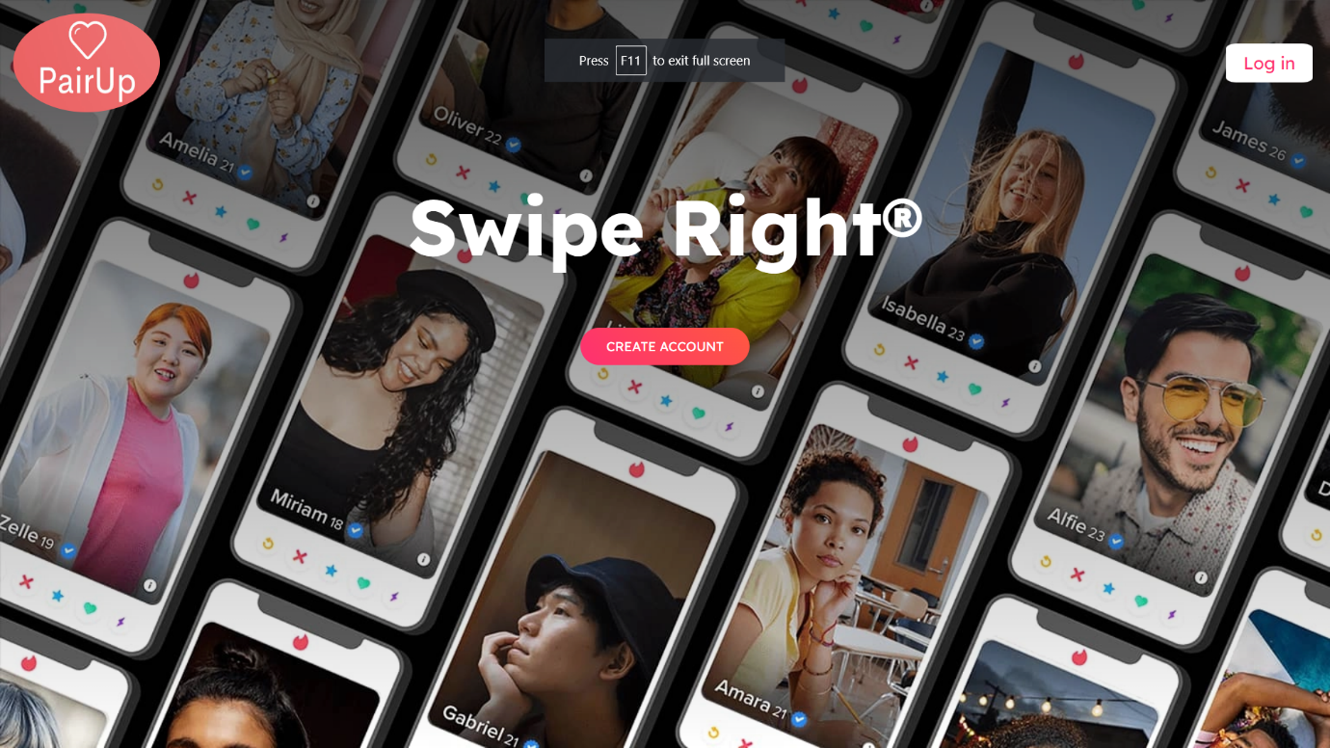Our dating app project was successfully implemented with a modern and user-friendly interface, and all the features we planned to include were successfully developed. The app was tested extensively, and all the functionalities were found to be working correctly.

This is the startup when you start the flask application, and we are going to see a login page, where it will ask for email ,and password and if you don’t have a password, we can register here.

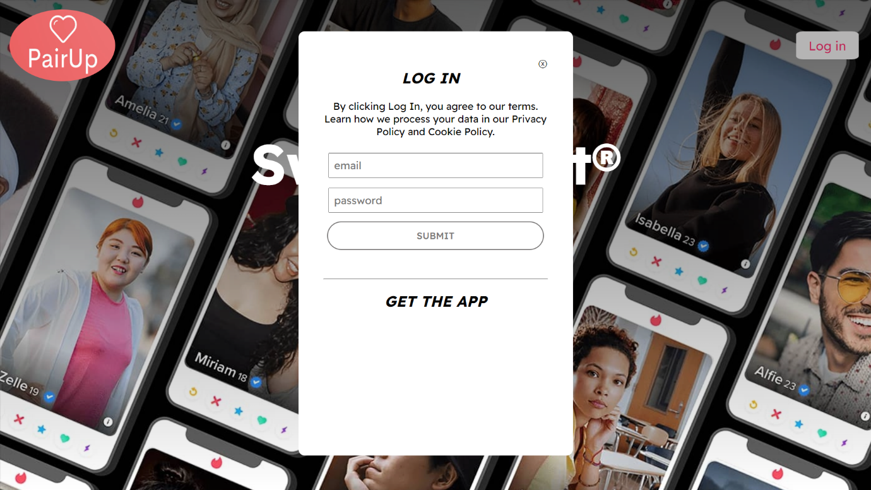

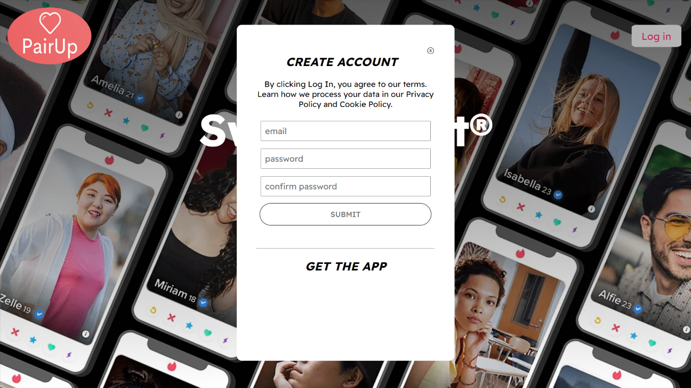This is the Register Part of the web application, where the user is able to register by adding the name, email and password.

Set up your profile. Once your account is created, you will need to set up your profile. Upload a profile picture and add some information about yourself, such as your bio and interests.

Set your preferences: Tinder uses your preferences to suggest potential matches. Set your gender, age range, and location preferences to narrow down your search.

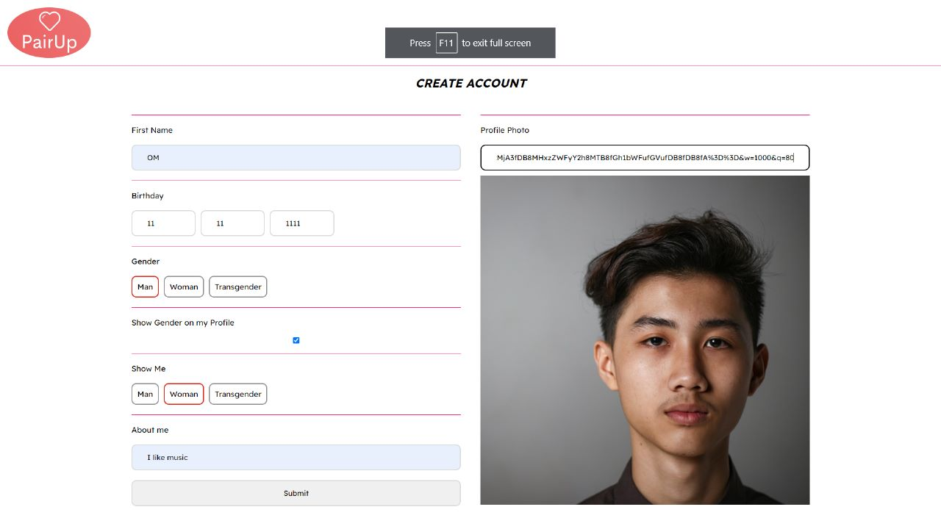

Start swiping: Tinder uses a swiping mechanism to indicate whether you are interested in a potential match or not. Swipe right if you're interested and left if you're not.

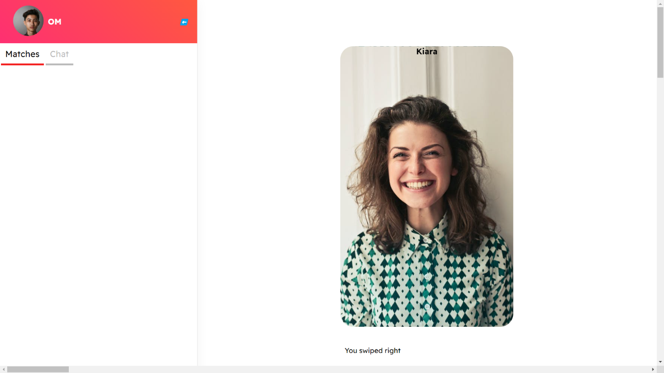

If both parties swipe right, it's a match!

Start messaging: Once you have matched with someone, you can start messaging them. Click on the chat icon to send a message to your match.

1. 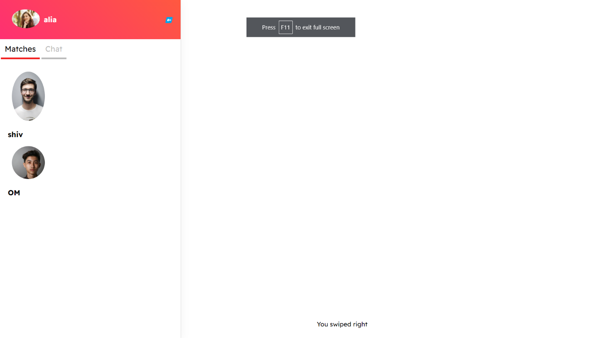Manage your matches: You can view your matches by clicking on the chat icon. From here, you can manage your matches and start messaging them.

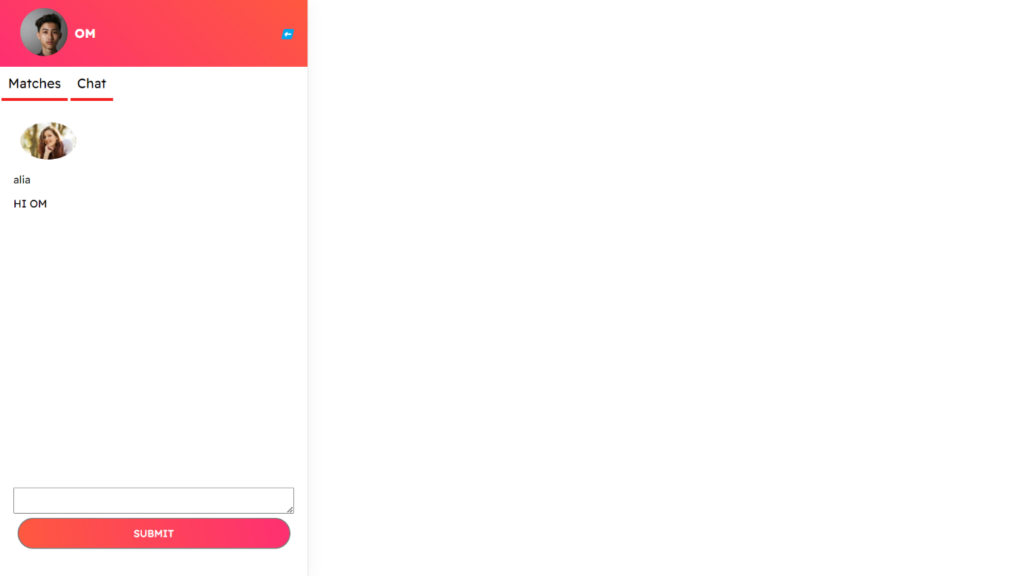

Manage your matches: You can view your matches by clicking on the chat icon. From here, you can manage your matches and start messaging them.

**Conclusion and Future work**

In conclusion, our dating app project successfully met its objectives of developing a modern and user-friendly dating app with advanced matching algorithms and messaging features. The implementation of React and Redux for the frontend and Node.js and Express.js for the backend allowed us to create a seamless user experience while maintaining the app's performance and security. Our use of a payment processing system also provides users with additional premium features to enhance their experience.

Future Work: While our dating app project has been successful, there is always room for improvement and expansion. Here are some possible future work plans:

1. Enhancing the Matching Algorithm: The current matching algorithm of our dating app project is based on basic user preferences. In the future, we can add more complex algorithms that take into account more specific factors such as location, interests, and behaviors.
2. Improved User Experience: We can continuously improve the user experience by refining the app's user interface, enhancing the messaging system, and introducing more interactive features such as voice and video calls.
3. More Robust Security: As online dating apps are prone to security threats, we can continuously improve the security of the app by introducing two-factor authentication, more advanced encryption, and more comprehensive user verification processes.
4. Integration with Social Media: We can integrate the app with social media platforms to enable users to connect and share their dating experiences on other platforms.